The Bible

Welcome to kids church – introduce junior and freedom riders leaders for the morning.
Celebrate July Birthdays

Intro
We are starting a new series today called the Bible adventure! We are learning about what the bible is and will be exploring the wonderful things inside!

Opening questions
How can books be helpful and good for us?
What is your favourite type of book?
Does anyone have a bible at home?
It is probably the oldest book you have because it was written a long time ago!
It is full of stories, poems, songs, adventures, lessons, history, dreams and letters!
Does anyone know what the word bible might mean?
Books or library. The bible is lots of books collected and stuck together.
How many books do you think there are?
There are 66 books divided into two sections. The old testament which talks about the promise of Jesus coming to rescue us and the new testament that is all about how Jesus came and is with us.
It is a very special book that was put together a long time ago. The writers were inspired by God. It is a very powerful and interesting and helpful book!

Snack and story
Read ‘Learning about the bible’ during snack time.
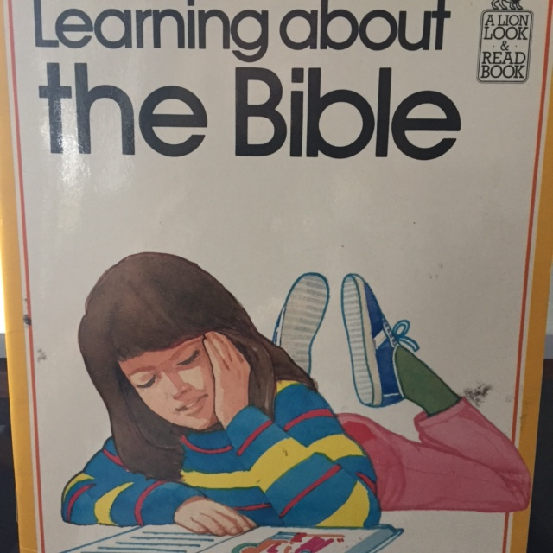

Seniors – Verse, discussion, game.
Materials: A lamp or candle preferably in a dark room. Print out of verse. Props or pictures for sharing. Tea towel or blindfold and object to hide.
The bible is like a torch or light that helps us find the right way to go. Let’s sit in circle around this light. Does anyone remember this verse?
Show poster of verse below.
http://www.juxtapost.com/site/permlink/2a903750-a8b3-11e2-bc85-517b927753a4/post/34your_word_is_a_lamp_to_my_feet_and_a_light_to_my_path34/
I would like to tell you about how the bible has been like a light for me. Try and give specific examples of how you read the bible and a time or ways that it has been like a ‘light to your feet.’ Use props or pictures to keep the kids attention eg. A mug if you read the bible over a cup of tea or a picture of someone who you gave a special verse to.
Ask the kids about their experiences of reading the bible and encourage them in this.
Closing Prayer
I would like to pray for each of us. Lord, help us to read your word and let it be like a light for us in our lives.
Amen.
Game
We are going to play a game where someone can’t see, they have a challenge but we are going to help them out!
Have someone leave the room while you have another kid hide something (like a ball). Now, the kid outside the room is blindfolded and then brought back into the room. All the players must now give verbal clues to the blindfolded person to help them find the object. When they find it, they have to guess who hid it. If they are right, that kid goes next. If not, they get to be blindfolded again.
http://www.kids-partycabin.com/blindfold_games.html

Juniors – Discussion and game.
Materials: A lamp or candle preferably in a dark room. Print out of colouring page and pens. Props or pictures for sharing. Tea towel or blindfold and objects in pillow slip.
The bible is like a torch or light that helps us find the right way to go. Let’s sit in circle around this light.
I would like to tell you about how the bible has been like a light for me. Try and give specific examples of how you read the bible and a time or ways that it has been like a ‘light to your feet.’ Use props or pictures to keep the kids attention eg. A mug if you read the bible over a cup of tea or a picture of someone who you gave a special verse to.
Ask the kids about their experiences of reading the bible and encourage them in this.
Closing Prayer
I would like to pray for each of us. Lord, help us to read your word and let it be like a light for us in our lives.
Colouring page or game
Kids can now do a colouring page
http://www.biblewise.com/kids/fun/coloring/the-lighted-path.php
or play a game where someone can’t see but they use their hands to tell us about something in my mystery bag! http://busyteacher.org/6580-what-you-can-do-with-a-blindfold-10-fun-esl-games.html
Game
Place several items inside a bag or pillow slip. Kids take it in turns of wearing a blindfold, picking out an object, describing what they feel and guessing what it is.

