Intro

Today is a special holiday celebration.
Today we come together as church community to bless God for the season of Spring. For spring in creation, for spring times in our lives. For change and growth and new things.
First, Let’s spend a moment or two in quietness.
Consider the winter that is drawing to a close. Picture the fallen leaves and bark of winter breaking down now, giving the soil nutrients for the growth to come.
Picture the signs of new life in your neighbourhood, the stirrings of new growth in the garden and bush, the insects that are returning, the warm smells in the air, the lengthening days.
Let’s rest in the presence of our creator, life and love in every season.

Play clip – Idea for 2018 https://www.youtube.com/watch?v=-E5A_uZjhsw

Opening Prayer - Emily
(A call and response prayer idea from past years)
Emerging Prayer
A sleeping world emerges to new possibilities,
For the cycle of life Which brings death and rebirth
A. We rejoice in the promise of Spring For lengthening days, for time to play after dinner
And sunlight’s warmth upon the soil and our faces
A. We rejoice in the promise of Spring
For colour, design and renewal in creation and in our stories
Reflecting our Creator’s artistry
A. We rejoice in the promise of Spring
For new life, for clean slates, for the noisy baby magpies
Their joy and exuberance
A. We rejoice in the promise of Spring
For all of creation
And the majesty of its Creator
A. We rejoice in the promise of Spring
Australian take on a prayer found here: http://www.faithandworship.com/Prayers_Spring.htm

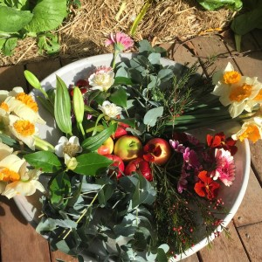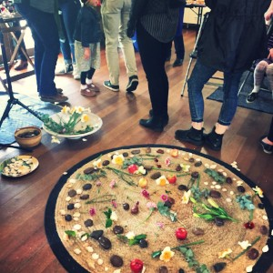

Spring Mandala
We are going to make our annual spring mandala now as we pray for the season to come and commit to God the season that is passing.
Mandala is a word that means “sacred circle.” Making a mandala is a spiritual practice in many religious traditions. They are used for meditation, healing and personal growth. A circle is a symbol of wholeness and unity. Working on a mandala helps us focus inward.
I invite you to take a rock – Think about something from this past season that you would like to give to God for new possibilities or a new story to grow from it. This might be something that you desire to put to rest. Perhaps there is an area of life that you are tired or weary from. Something needing change and new life.

Play music – Idea for 2018 https://www.youtube.com/watch?v=JNCfawuhZPw&index=2&list=PLp-fJC3Efxvxy6CMuCVEmEbq3QJ83naHr

Take a leaf or flower – Think about a New thing the you can see God has been doing in your life this past season, something unfolding, healing, changing.Perhaps it is a friendship, a new attitude to your work or school, a new opportunity or focus, a new garden, book or hobby..
Now I invite you to place the rock, as a prayer for newness and the flower or leaf – as prayer of thanks for growth and a new season on the Spring mandala mat.

Play music

Offering & Announcements – Picnic service next week at 10:30amBYO brunch picnic Elizabeth Bridge Reserve, Durham Rd Kilsyth.

Spring Offering Prayer
Offertory Prayer (from "Care of the Earth" liturgy by the Rev. Jennifer Edinger)
Loving God, we are surrounded by the beauty of creation. We are supported by the abundance of creation. We gratefully receive your gifts of love and life--gifts which fill our lives with joy and satisfaction.
In thankful response to your generosity, we place before you pieces of ourselves and of your creation--food from the earth we till, energy from the moments of our life, money from the skills you give, bread from the seeds that were sown and wine from the grapes that grow, and our abundance to share with others. Receive them as signs of our love and gratitude.

Offering spotlight - Community Prayer & Praise
Ask the community if there are any things we can pray for or stories to share that we can be thankful for & pray.

Items
(I often have a creation psalm ready as back up if another item is needed eg psalm 104, psalm 19, psalm 8, psalm 29)

Closing Prayer idea

Together we say
We bless you,
God of Seed and Harvest
And we bless each other
That the beauty of this world
And the love that created it
Might be expressed though our lives
And be a blessing to others
Now and always
AMEN

http://www.faithandworship.com/Imbolc_praying_though_the_Celtic_year.htm#ixzz27Y0IeKuB (Faith and Worship)

