Samuel Listens to God
Materials: Snack for story time, print outs below, props for story, cups, string, pencil, textas and paper clips (optional).

Intro

Today we begin a new season where we explore kid heroes of faith in the bible. Today we will hear the story of Samuel from the book of Samuel.

Opening question: What is one of your favourite sounds?

Well, let’s listen to the story now and find out what Samuel heard one night when he was a kid like you.

Story & Snack
This story is acted out using the props slowly and deliberately. The focus being on the story itself not the audience.

Materials: Print pictures below (If you have time stick them onto cardboard so they sit up easily.) Big piece of fabric (preferably red), tea towel, a box of some kind to represent the ark, candle or little light, pegs to help make the tent and prop figures up.

Setting in front of kids: To make temple drape fabric over a chair to make a tent-like situation with an entrance at the front. Tea towel symbolising Hannah’s home on the floor a little distance from the temple. Picture of Eli by the opening / door.

At the time where our story begins Eli the priest was working in the temple with his two sons.
One day, Eli was sitting by the door. A woman came in. Her name was Hannah.

Place picture of Hannah inside the entrance.

She was crying. She had come to Shiloh with her husband to worship God. Hannah prayed in her heart, 'Oh God, I am so unhappy. Please give me a son. If you do, I will give him to you.'
Eli thought at first that Hannah had been drinking. But when he realized she was sad, he blessed her. Hannah stopped crying and went home with her husband.

Walk Hannah slowly over to the tea towel.

God remembered Hannah and answered her prayer. She did have a baby. She called him Samuel.

Cradle the baby in your hand and peg it onto Hannah.

Hannah remembered her promise to God. When Samuel was three years old, she took him to the temple.

Walk Hannah slowly back to the temple.

Do you remember me? I stood here and prayed for a son. God has answered my prayer. So now I give my son to God to work in the temple.'

Replace Hannah with boy Samuel figure.

So Samuel served in the temple. Every morning he opened the inner courtyard doors and did a priest's work.

Open the curtains of the tent back to reveal the box.

Every night he slept by the ark which was a big chest that held special, sacred things in it. (scriptures, a bowl of manna, Aaron’s staff if the kids ask.)
And every year, as he grew too big for his clothes, his mother brought him a new coat.

Place Eli’s sons at the temple.

Eli's two sons were priests, too, but they were greedy and bullying.
Eli warned his sons to start doing what God wanted but they did not listen.
Samuel grew and was loved by God and by the people.

Make Samuel lie down by the box and move to Eli at the right times.

One night, Samuel heard a voice. 'Samuel!'

Place candle/light next to Samuel to symbolise God’s presence.

Samuel ran to Eli. 'Here I am. You called me.'
'I didn't call; go back and lie down’ said Eli.
Again, Samuel heard a voice. 'Samuel!' Again Samuel ran to Eli. 'Here I am; you called me.' 'I didn't call said Eli. Go back and lie down.'
'Samuel!' Again Samuel ran to Eli. 'Here I am; you called me.'
The third time, Eli realized it was God calling. 'Go and lie down, and if he calls you, say, 'Speak, Lord; your servant is listening.'
'Samuel!' This time Samuel knew what to do.
'Speak, Lord; your servant is listening’ he said.
God came so close to Samuel and Samuel listened to what God wanted to say to him.
He lay by the ark until morning, and then opened the inner shrine doors. But he was afraid to tell Eli what God had said.
Eli called him: 'Samuel, my son.'

Bring Samuel out next to Eli.

'Here I am.' 'Tell me everything God said. Don't hide anything from me.' So Samuel told Eli that God would bring Eli's naughty family to an end.
‘He is the Lord.’ Said Eli. ‘Let him do what is good in his eyes.' From that time on, God was with Samuel as he grew up, and Samuel kept listening to God. God kept speaking to Samuel and giving him messages for people. Everyone recognized Samuel as a prophet.

Questions for Discussion

I wonder what you like best about this story?
I wonder how Samuel felt when he heard God's voice?
I wonder if you have heard God calling you or speaking to you?
What are some of the ways God speaks to us or lets us know things?
I wonder what God is wanting to say to us in this story?

Ideas for this story were from:
http://www.barnabasinchurches.org.uk/the-big-story-footsteps-to-the-feast-for-bible-sunday/#

Prayer Activity – Cup Phones.

Materials: paper cups (2 per person), string, skewer or sharp pencil to poke holes, textas.

God speaks to us in different ways, it is good to let God know that we want to hear Him each day and pay attention to anything God might want us to know or do.

Let’s decorate a cup telephone with a prayer that we can say each night or morning to let God know we are ready to listen and do the good things he has planned for us.

Memory Verse to write on cups:
“Speak Lord, I am listening.” 1 Samuel 3:10

Closing Prayer
Invite the kids to hold their hands over their ears.
God we pray a blessing on our ears. May we listen out for you, protect our ears from bad things, may we hear your love for us in all that we do.
Amen.

Make a String Telephone
For each kid you'll need:
- 2 paper cups
- A sharp pencil or skewer to help poke holes
- String (kite string and fishing lines work well)

Instructions:
- Cut a long piece of string.
- Poke a small hole in the bottom of each cup.
- Thread the string through each cup and tie knots at each end to stop it pulling through the cup (alternatively you can use a paper clip to hold the string in place).
- Move into position with you and a friend holding the cups at a distance that makes the string tight (making sure the string isn't touching anything else).
- One person talks into the cup while the other puts the cup to their ear and listens, can you hear each other?

Extra Game
Chinese whispers

How to play:
Get everyone to sit around usually in a circle. Choose a phrase or short sentence and write it down for the person to start the game – he or she simply whispers the phrase into the person’s ear next to them.
That person now passes the phrase to the next person and so on. The last person in the group stands up and announces the phrase to the group. The person with the note with the phrase written on it will check if this is the exact phrase at the start of the game.
If this is correct, you might want to award a prize to the group. If you have a lot of kids, perhaps split them into teams and give them the exact phrase each and see which team completes the whisper correctly.
Read more: http://www.essentialkids.com.au/activities/parties/chinese-whispers-20111213-1oshf#ixzz44xP58xNf
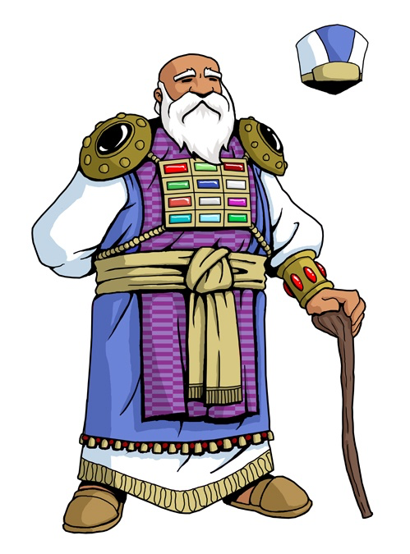

http://www.biblestudywithrandy.com/wp-content/uploads/2015/11/eli.jpg

http://www.friendsandheroes.com/sites/default/files/mary%5B1%5D.pnghttp://www.friendsandheroes.com/sites/default/files/mary%5B1%5D.png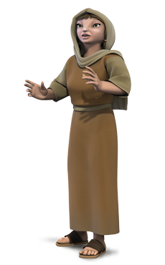
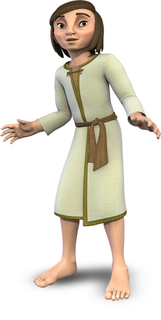
https://assetsnffrgf-a.akamaihd.net/assets/m/ia/ia.art/1102013254_univ_cnt_3_xl.jpg

http://www.allfree-clipart.com/People/Baby/swaddled_baby.jpg
Miriam has a good Idea
Materials: Snack for story time, download story on ipad/computer or props for story, ziplock bag for each kid, water, baby oil, blue food dye, glitter or small toys (optional) tape.

Welcome

Intro

Today we are in the second week of a season where we explore kid heroes of faith in the bible. Last week we heard the story of Samuel and how even as a kid God spoke to him and he listened. Today we will hear the story of Miriam who God gave an amazing idea to.

Opening question: What is a good idea that you have had lately?

Well, let’s listen to the story now and find out what Miriam got up to when she was a kid like you.

Story & Snack

Play clip https://www.youtube.com/watch?v=gUs0XNFB_4c&nohtml5=False

or do idea below:

This story is acted out using the props slowly and deliberately. The focus being on the story itself not the audience.

Materials: Print pictures below (If you have time stick them onto cardboard so they sit up easily.) Big piece of blue fabric eg. sheet, tea towel, a matchbox to represent the basket, pegs to prop figures up.

Setting in front of kids: Make a river with the blue fabric with grasses on edge. Tea towel symbolising Miriam’s home on the floor a little distance from the river.

The Story of Baby Moses

This story comes from the Old Testament, long before Jesus was born in the land Egypt. We begin this story in the land of Egypt. There were now a lot of Israelite people people who loved God living in Egypt.

Place King figure in the centre of the space.

Anyway, a new king who was called Pharaoh came into power in Egypt. He didn't like it that there were so many Israelites and he thought they would one day take over the land. So he decided to make all the Israelites into slaves.
He made them work from early in the morning till late at night doing very hard work. Even if they were tired the Egyptians wouldn't give them a break, they would just make them work harder. It was very bad.
Pharaoh did all this and he still wasn't happy. The Israelites were still growing in number so he decided to make a law. If any boys were born to the Israelites he would have them killed.
At this time there was an Israelite couple who were expecting to have a baby.

Place Jochebed and Miriam and Moses on tea towel.

When they had a baby boy (whose name would later be Moses) they decided to hide him because they wouldn't let anyone kill this beautiful, precious baby of theirs.
They hid Moses for three months, but as he got older he didn't sleep as much and he cried louder than before. So his parents did the only thing they could do, they made a strong basket (sort of like a mini baby boat) and put blankets around the baby and placed the basket in some tall grass in the Nile river.

Place baby gently in basket and place basket in the water. Place Miriam nearby behind grasses.

Baby Moses had a sister named Miriam, and she watched from a distance to see what would happen to her baby brother. While she was watching she saw somebody coming, she realized it was Pharaoh's daughter and her servants. They were dressed like they were famous, and she had seen her before and remembered what she looked like.

Place princess in water near the basket.

Pharaoh's daughter had come for a swim. While she was swimming she noticed a basket floating a little ways away in the tall grass. So she asked one of her servants to go see what it was.
The girl brought the basket over to her, and when Pharaoh's daughter opened it, the light startled Moses so he woke up and started to cry. "What a sweet, beautiful little baby. It must be one of the Israelite's,"Pharaoh's daughter said to her servants.

Bring Miriam out from behind the grass and close to princess.

Miriam had seen what had happened, and she hurried over and asked, "Would you like me to go find an Israelite woman to feed the baby for you?"
"Yes, go and find someone who can nurse the baby." she answered.

Bring Miriam to mother and return them to princess.

Miriam ran as fast as she could and told her mother that Pharaoh's daughter had found him and wanted someone to come nurse him.
They went and found Moses with Pharaoh's daughter, and she asked them, "Please help me and nurse this baby, and I will pay you for helping me." (She didn't realize that this was actually Moses' mother).
Later he became the son to Pharaoh's daughter, and that's when she named him Moses, which means she got him out of the water.

Story from: http://www.dltk-bible.com/p.asp?p=http://www.dltk-bible.com/exodus/pstory_of_baby_moses_cv.asp

Questions for Discussion

I wonder what you like best about this story?
I wonder who had the most difficult time in this story?
I wonder how Miriam felt when the princess found Moses?
I wonder when God has given you a helpful idea or courage to do a tough job?
I wonder what God is wanting to say to us in this story?

Prayer Activity – Sensory Bags

Materials: ziplock bag for each kid, water, baby oil, blue food dye, glitter or small toys (optional) tape.

Instructions here: Instructions here: http://familylicious.com/oil-and-water-sensory-bag/

God gives us what we need when we ask him to help us. At this point you may like to share a time recently when God has given you a good/helpful idea. In the bible it says:

Memory Verse:
“Don’t worry about anything, but pray about everything.”
Philippians 4:6-7 (CEV)

Let’s make a water bag to remind us that God fills us with good ideas to make our lives full of love. He has the answers to all our problems. We only have to ask!

Closing Prayer

End the time by asking the kids if there is anything they need God to help them with at this time and pray together.

Memory Verse: Does anyone remember our verse from last week about listening to God?
“Speak Lord, I am listening.” 1 Samuel 3:10

Extra Game or Colouring sheet to print here:

http://www.colorluna.com/put-baby-moses-to-basket-to-save-him-coloring-page/

Balloon Volley Ball

What you need
- String
- Balloon

Activity
Suspend a piece of string across the room are at approximately head height.
Divide players into two teams and position them on either side of the string.
One team serves by hitting the balloon over the string and the other team must return the balloon without allowing it to fall to the ground.
When the balloon is not returned, the other team scores a point.
First team to reach 10 points wins.
http://www.kidspot.com.au/things-to-do/activities/balloon-volleyball

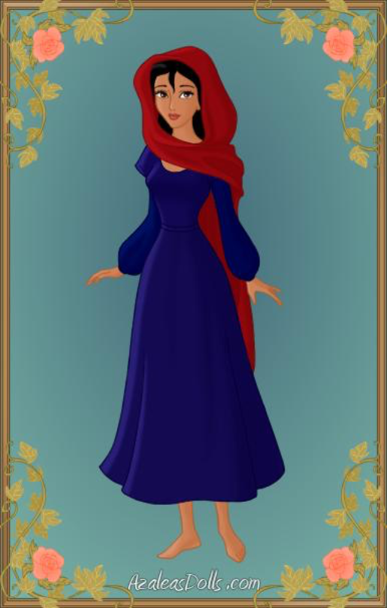

Jochebed, mother of Moses.
http://www.deviantart.com/art/Jochebed-Mother-of-Moses-The-Prince-of-Egypt-384233584
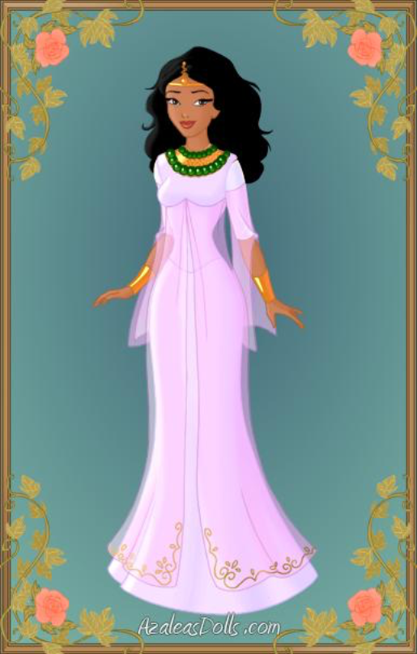

The Princess.
http://jjulie98.deviantart.com/art/The-Queen-The-Prince-of-Egypt-385113671

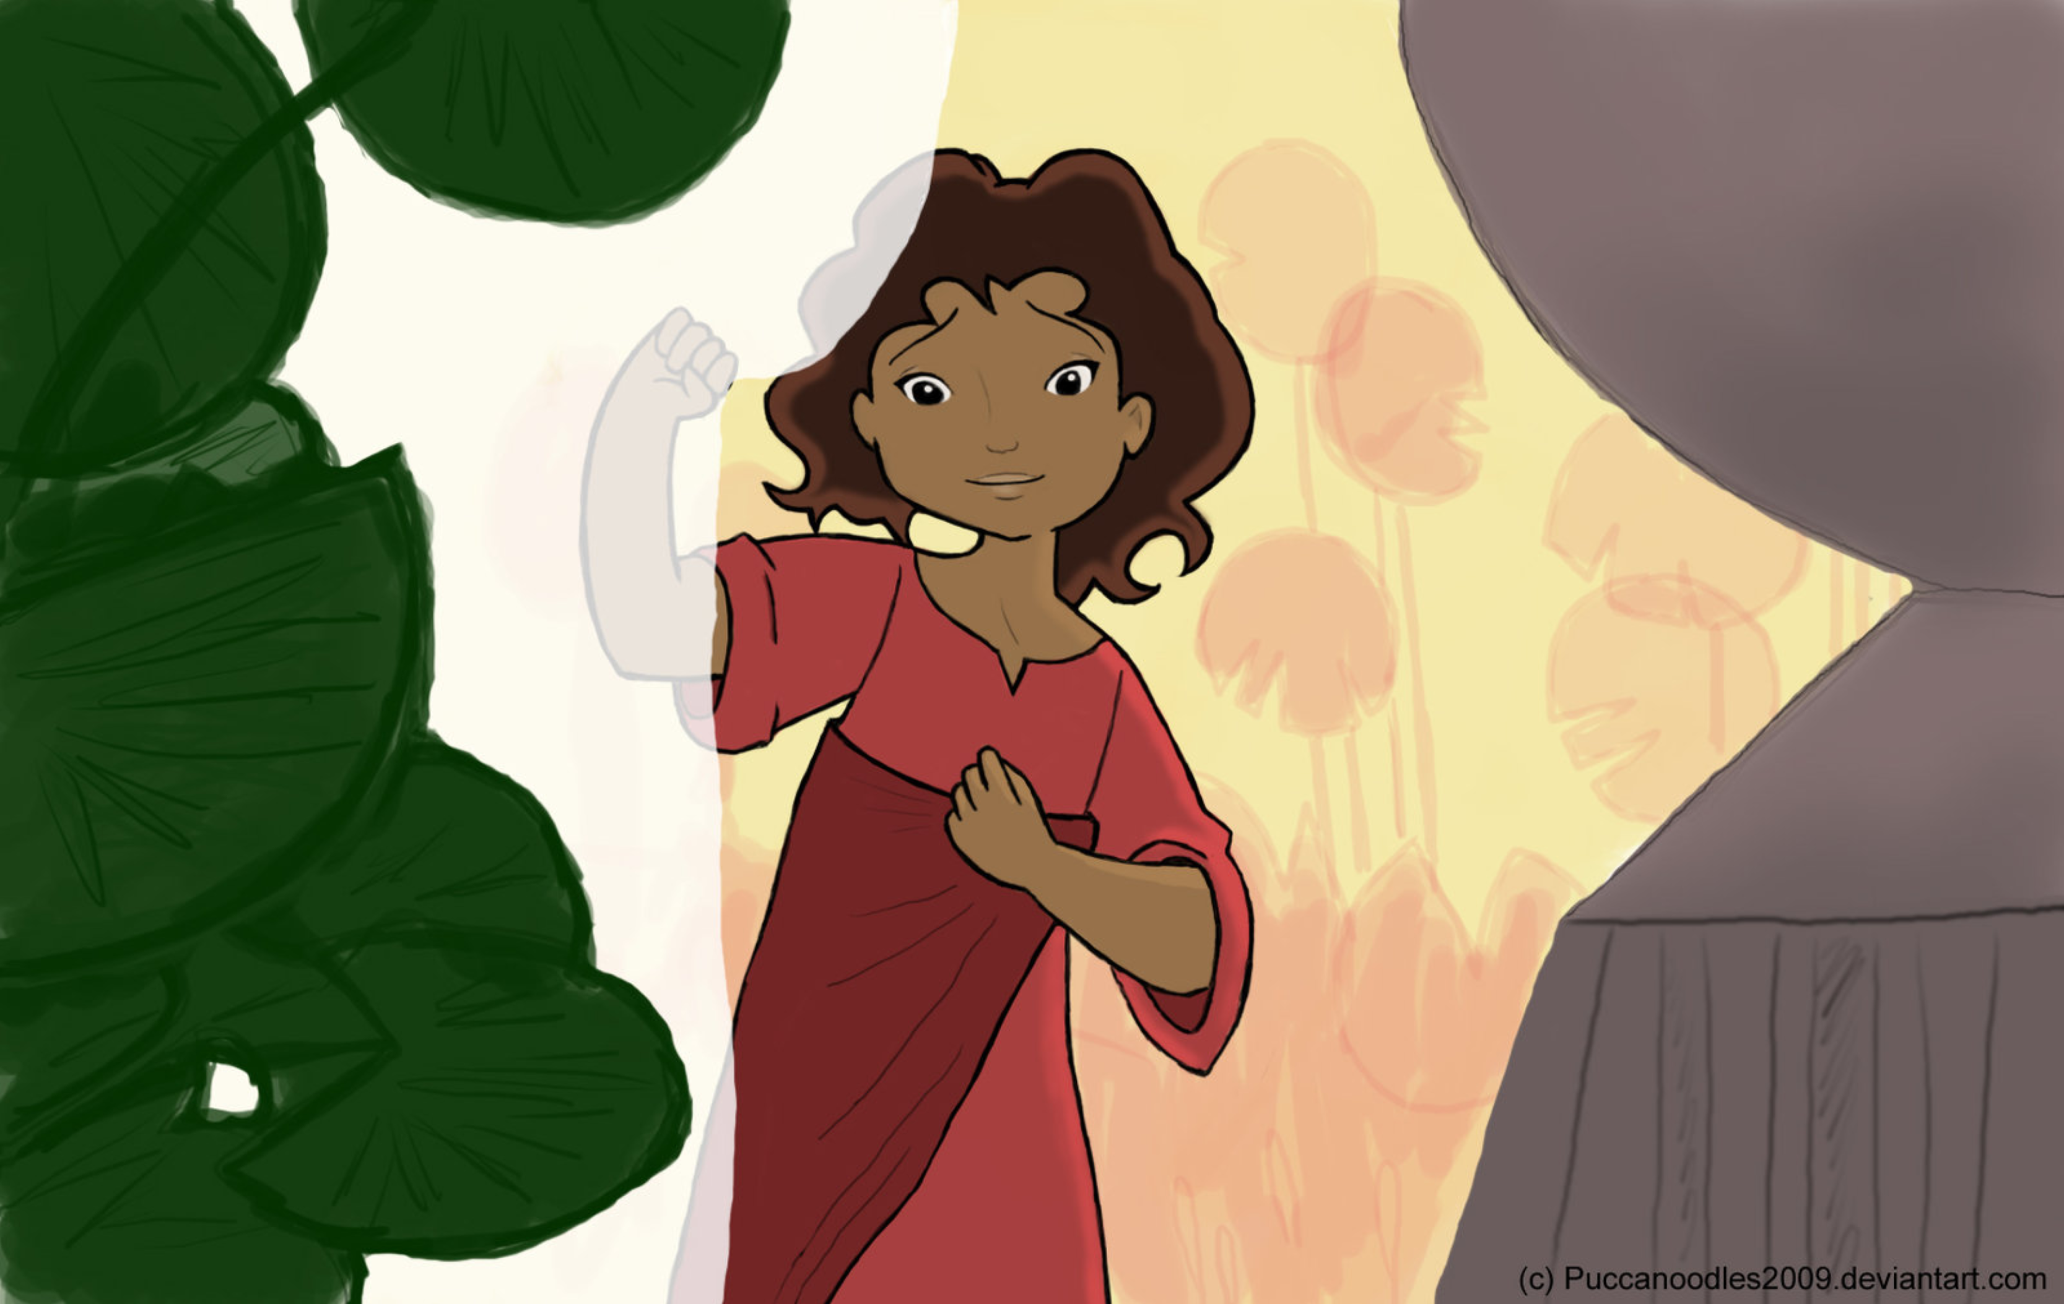

Miriam

http://img15.deviantart.net/ca64/i/2010/238/7/b/deliver_us_by_puccanoodles2009.jpg

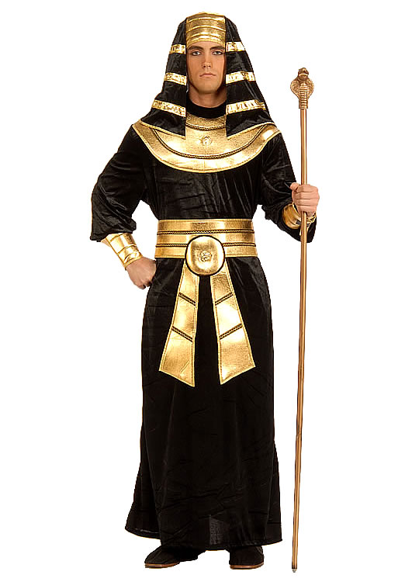

http://www.halloweenmart.com/media/core/FO60442_ADULT_PHARAOH_COSTUME.jpg

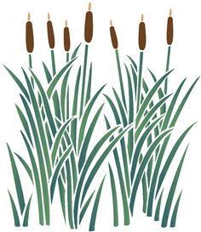

https://s-media-cache-ak0.pinimg.com/236x/4c/11/21/4c1121d1e9ab36fbb08c6c0412419144.jpg

http://www.allfree-clipart.com/People/Baby/swaddled_baby.jpg
Daniel stays strong

Materials: Snack for story time, clip of story or bible story of Daniel to read, Print out template for each child, textas or pencils for each kid, glue and craft materials (optional), music player.

Welcome

Intro

Today we are in the third week of a season where we explore kid heroes of faith in the bible. We have heard the story of Samuel and how even as a kid God spoke to him and he listened. We have heard the story of Miriam and how God gave her an amazing idea. Today we will hear the story of Daniel who was strong and clever in all he did because he listened to God.

Opening question: Have you ever had a weird dream?

Well, let’s listen to the story now and find out how God showed Daniel about a King’s dream when he was a kid like you.

Story & Snack

Play clip https://www.youtube.com/watch?v=ZQlBaYSGdhg

or

read out the Daniel story from this passage: https://www.biblegateway.com/passage/?search=Daniel+1&version=GNT and display the picture below.

Questions for Discussion

I wonder what you like best about this story?
I wonder how Daniel felt when he was taken from his family to serve in the palace?
I wonder why the King gave him such big jobs?
Have you ever asked God to keep you safe? What happened?
I wonder what God is wanting to say to us in this story?
Remember it is great if the leaders can share their stories.

Prayer Activity – Door Hanger Verse

Materials: Print out template for each child, markers, glue and craft materials (optional). (Markers and glue in box)

Template for door hanger: http://scrappinaroundtheclock.blogspot.com.au/2012/11/tutorial-wednesday-door-hanger.html

Daniel was able to stay strong to his faith and live the right way and hear from God even in a land where no one else did.
Daniel prayed every morning, lunchtime and night by his window and God gave him strength to be a good leader.
The bible says:

Memory Verse
I can do all things through Jesus who gives me strength.
Philippians 4:13.

Let’s make a picture about this special verse that remind us that God gives us the strength to do anything and everything that each day brings.

Closing Prayer:
End the time by asking the kids if there is anything they would like to say to God at this time and pray together.

Memory Verse: Does anyone remember our verse from last week about asking God for help?
“Don’t worry about anything, but pray about everything.”
Philippians 4:6-7 (CEV)

Extra Game: Musical statues or musical chairs.
Materials: Music player, chairs (optional)

Musical Statues
Have the children move around the room while the music is playing.
Children are free to dance or run around until the music stops.
Once the music stops children are to freeze where they are and not move.
The child who moves first is out of the game.
If all of the children are doing an excellent job of remaining still restart the music.
Eventually children will flinch and you will get a winner.

Musical Chairs
The chairs are set up in two rows back to back (one chair less than the number of players).
The music is turned on, and the players walk around the chairs.
When the music stops the players race to sit in the available chairs.
The player left standing is taken out of the game.
The players all stand again and a chair is removed.
The music is started and the walk around the chairs begins again.
This procedure is continued until only one person remains.
This person is the winner.

http://www.kidspot.com.au/things-to-do/activities/musical-chairs

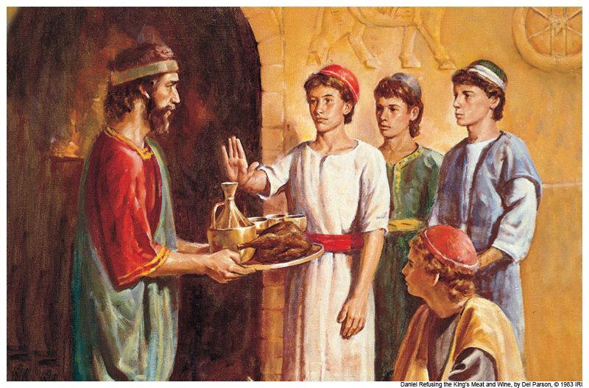

http://versebyversebibleteaching.com/wp-content/uploads/2012/10/DanielRefusingTheKingsFoodAndWine.jpg
The Brave Servant Girl

Materials: Snack for story time, download of story below or print out of story and bowl of water, Glasses of soda water for each kid, sultanas. Download of joy joy song or colouring page for each kid.

Intro

Today we are in the fourth week of a season where we explore kid heroes of faith in the bible. We have heard the story of Samuel and how even as a kid God spoke to him and he listened. We have heard the story of Miriam and how God gave her an amazing idea. We have hear about Daniel who was strong and clever in all he did because he listened to God. Today we hear the story of Naaman’s servant girl.

Opening Question: Have you had to be brave about something this week?

Story & Snack

Today’s story is about a very brave little girl who was one of God’s people the Israelites along time ago, about 900 years before Jesus was born . There was a war and she was taken prisoner and became a slave to Naaman and his wife. Naaman was a commander of the Syrian army who fought the Israelites and very respected by his king. The servant girl, our hero today doesn’t even get her name mentioned but we know she was a kid just like you and worked as a slave in Naaman’s home doing things like cooking meals, and bathing and dressing her mistress, Naaman’s wife.

Let’s listen to the story now and find out how this servant girl did something very brave when she was a kid like you.

Download clips here https://www.youtube.com/playlist?list=PLUD8WkjRmB4mYBPfcCuNYe8vvoS94zIsJ

Or

Read story from here http://gardenofpraise.com/bibl18s.htm
And display picture below and a bowl of water.

Questions for Discussion

I wonder what you like best about this story?
I wonder why the servant girl told her mistress about Elisha?
I wonder why Naaman trusted the servant girl?
Have you ever asked God to care for someone who doesn’t know Him? What happened?
I wonder what God is wanting to say to us in this story?
Remember it is great if the leaders can share their stories.

Prayer Activity – Fizzy Science Prayer

Materials:
Glasses of soda water for each kid, sultanas.
See here for instructions:
http://www.learning4kids.net/2013/01/16/science-fun-dancing-sultanas/

The servant girl loved God and bravely shared about his power to heal even in a country that had a different religion. God looked after her and used her to bless that family.

God brings us into each others lives to help each other know and experience God’s love.

When we stick close to God and talk to him often, he will show us throughout the day how he loves us, how we can help each other.

We are going to do a science experiment as we pray today.

Fizzy Listening Prayer

Each day we can let God know we love him, we can let him know that we are ready for anything he wants us to know or do today.

Leader drops four sultanas in the fizzy water as you say “I- love –you- God”

When we do this ideas and blessings will come to us through the day just like these sultanas will rise to the surface. Even if they are as little as feeling happy or feeling you should smile back at someone, they are important and special.

You can drop some sultanas in the water now as you let God know that you love him, that you ready for anything. Then watch the sultanas rise up and down and take notice of anything God brings to your heart.

Closing Prayer

Thank you God for the servant girl. Thank you that you help us to love one another and help each other. We pray that you will look after us too and help us to listen to you each day and be brave like the servant girl. Amen.

Memory Verse:
Does anyone remember the verse we learnt last week that reminds us that Jesus can help us be strong for anything we do?

I can do all things through Jesus who gives me strength. Philippians 4:13.

Extra Game:

Joy Joy Song:
https://www.youtube.com/watch?v=LylgwOEI7AY

Divide the group into ‘hearts’ and ‘wheres’ and they have to stand up when ‘heart or ‘where’ is sung. They all have to wave their arms for ‘Happy!’

or

Colouring Page:

http://azcoloring.com/coloring-page/1676927?album=naaman-coloring-pages

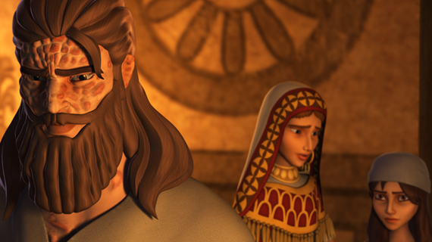

http://uk-en.superbook.cbn.com/content/servant-girl-shares-naaman
Courageous David

Materials: Download story below or bring story of David to read, Balloons, permenant marker, bi-carb, bottle with some vinegar in it.
Ball or (Rubber bands, paper, paddlepop sticks).

Intro

Today we are in the fifth week of a season where we explore kid heroes of faith in the bible. We have heard the story of Samuel and how even as a kid God spoke to him and he listened. We have heard the story of Miriam and how God gave her an amazing idea. We have heard about Daniel who was strong and clever in all he did because he listened to God. We heard the story of Naaman’s servant girl and how her bravery saved a whole family. Today we hear the story of another courageous young boy called David.

Opening Question: Is there something you know you are good at?

Story & Snack

David who we are learning about today was good at playing music, writing songs and looking after his sheep.
Let’s listen to the story now and find out how David used his special skills when he was a young kid like you.

Play animation: https://www.youtube.com/watch?v=7zLAcUZkxHA

Or

Act out the story from 1 Samuel 17 (Contemporary English Version) or your favourite story book on David.

Questions for Discussion

I wonder what you like best about this story?
I wonder how David got so good with his sling?
I wonder when you have used your skills to do something God is really into? or Have you ever asked God to help you be brave? What happened?
I wonder what God is wanting to say to us in this story?
Remember it is great if the leaders can share their stories.

Prayer Activity & Memory Verse – Balloon Prayer

Materials:
Balloons, permenant marker, bi-carb, bottle with some vinegar in it.
Deets on how to do it here: http://flamecreativekids.blogspot.com.au/2013/03/david-and-goliath-assembly-good-to-be.html

David loved God and would sing to God while he looked after his sheep. David got good at his skills of writing songs and protecting his sheep. David knew God was with him and trusted God to help him do these things even when they were very dangerous. God gave David the courage he needed to use his skills even against a giant!

It’s a bit like this bottle. You wouldn’t think this bottle could blow up the balloon right now. Just as no one believed little David could fight Goliath.

Before the children arrive, take a balloon and fill it with about a teaspoon of bicarbonate of soda. It's quite easy to make the balloon seem as though it is empty as long as the children don't get close enough to touch it! Fix it to the neck of a bottle containing some vinegar.

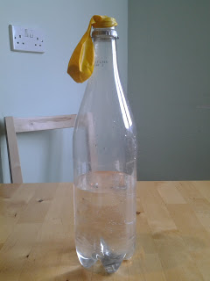

But... God was with David, just as God is with you and fills each of us with his Spirit.
At this point lift up the balloon and let the bicarbonate of soda be released into the bottle and explain that, even though no one else could see it, you knew there was something inside the balloon that could do the job. Watch the balloon inflate!
When God is with us we can do great things with our skills and talents. God can help you to do things that others might think you would never be able to!

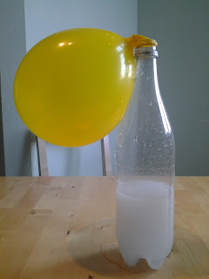
Closing Prayer

Invite each of the kids to open their hands and think about the things they like doing or are good at.
Thank you God that you fill us with gifts and your Holy Spirit so that we can live the best life and do amazing things. Please use our gifts and skills to love the world around us. Amen.

Memory Verse for this week:

Kids can write or draw the memory verse on their balloon:
Don’t ever be afraid or discouraged! I am the Lord your God, and I will be there to help you wherever you go. Joshua 1:9

Extra Game:
Materials: Rubber bands, paper, paddlepop sticks.

Make a simple version of these paper ball catapults.
http://4hbakerco.blogspot.com.au/2011/01/craft-stick-creativity.html

or

Play throwing a ball at a target.

Mary is Willing

Materials: Snack for story time, props for story, paper, textas, pipe cleaners or ribbon or string. Details in link below.

Intro

Today we are in the sixth week of a season where we explore kid heroes of faith in the bible. We have heard the story of Samuel and how even as a kid God spoke to him and he listened. We have heard the story of Miriam and how God gave her an amazing idea. We have heard about Daniel who was strong and clever in all he did because he listened to God. We heard the story of Naaman’s servant girl and how her bravery saved a whole family. We have heard about David who was full of courage because he knew God was with him. Today we hear about Mary and her willingness to be a part of God’s work.

Or

Opening Question

Have you ever wondered what angels look like? Well Mary who we are learning about today saw an angel. We will hear all about it soon.

Story & Snack

Mary who we are learning about today was just a teenager when the angel came to her. The angel told her that she was favoured by God, that God was pleased with her and she had been chosen for a special job.
Let’s listen to the story now and find out how Mary responded to God’s plans for her when she was a young teenager.

Read the story from Luke 1:26-38 CEV.
https://www.biblegateway.com/passage/?search=Luke+1%3A26-38&version=CEV
And display the picture below and some kitchen things like a bowl and spoon:

Discussion Questions

I wonder what you like best about this story?
I wonder why God chose Mary to have baby Jesus?
I wonder when you have felt God’s love for you?
Have you ever asked God if you can follow His plans for the day? What happened?
I wonder what God is wanting to say to us in this story?
Remember it is great if the leaders can share their stories.

Prayer Activity – Shoe Prayer
Materials: Paper, textas, pipe cleaners or ribbon or string. Details in link below.

Mary told God that she wanted Him to do whatever He likes with her life. She knew God has the best plans for us. Each morning we can say to God that we want to follow his plans for us today and he will bring us through the day in His way. We will see things and experience things the way God does.

Let’s make shoes to help us remember this prayer about following God each day. Write memory verse on thong.
Idea here: http://www.activityvillage.co.uk/design-your-own-flip-flops-craft

Closing Prayer

Invite each of the kids to hold their thongs.
Thank you God that you can guide us into our day. We want to follow your ideas for our life! Amen

Memory Verse for this week:

Kids can write or draw the memory verse on their shoe:

¹¹ For I know the plans I have for you,” says the Lord. “They are plans for good.

Jeremiah 29:11 (NLT)

Memory Verse:
Does anyone remember the verse we learnt last week that reminds us that Jesus can help us that God is always with us?

Don’t ever be afraid or discouraged! I am the Lord your God, and I will be there to help you wherever you go. Joshua 1:9

Extra Game:

Fruit Salad

Form a circle of chairs that is one chair fewer than a total number of players.
Nominate a player to be 'in', that player stands in the centre of the circle.
Divide all players into three groups of fruit by going around the circle and naming them either apple, orange or pear.
The player who is 'in', calls the name of a fruit.
If he calls out apples, everyone who is that fruit must get up quickly and change places.
Players who are not apples remain seated.
The person who is 'in' tries to sit in an empty spot whenever players swap positions.
If they manage to sit in a chair, the player not sitting in a chair is then 'in'.
The person in the middle can also call 'fruit salad' and everyone who is seated has to change spots.
The game can finish whenever you like.
http://www.kidspot.com.au/things-to-do/activities/fruit-salad-game

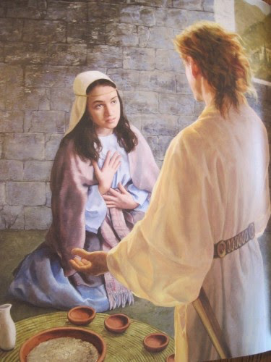
http://1.bp.blogspot.com/-hFBnl7QgYic/VNfwHNqC9CI/AAAAAAAAalE/wEkvFrLEl94/s1600/IMG_2125%2BAnnunciation%2Bof%2BMary%2Bfrom%2BGabriel.jpg

Joseph – God was his helper

Materials: Snack for story time, Coat or jacket, shopping bag (as bag of food), big plastic tub or laundry basket (as well), chairs set us as a prison, chair and cushion (as nice chair), Towel or fabric as royal robe.

Intro

Today we are in the seventh week of a season where we explore kid heroes of faith in the bible. We have heard the story of Samuel and how even as a kid God spoke to him and he listened. We have heard the story of Miriam and how God gave her an amazing idea. We have heard about Daniel who was strong and clever in all he did because he listened to God. We heard the story of Naaman’s servant girl and how her bravery saved a whole family. We have heard about David who was full of courage because he knew God was with him. We have heard about Mary who went with God’s plan because she knew his ways are best. Today we hear about Joseph and the ways God helped him.

Or

Opening Question:
Have you ever had a fight with your brothers or sisters? Well Joseph who we are learning about today had a big fight with his brothers. We will hear all about it soon.

Story & Snack

Materials: Coat or jacket, shopping bag (bag of food), big plastic tub or laundry basket (well), chairs set us as a prison, chair with cushion (nice chair), Towel or fabric as royal robe.

Joseph who we are learning about today was just a teenager when he got into a big fight with his brothers and got separated from his family for a long time.
Let’s listen to the story now and find out how God always helped Joseph.

Act out the story below.

The Story of Joseph
Can Joseph stands up and wave?
This is the story about a young man named Joseph. His father's name is Jacob, and they lived in Canaan from where his grandfather was from.
Joseph was seventeen and he had eleven brothers; and only had one brother younger than him. .
Can some brothers stand up and wave?
Joseph was one of the youngest sons, his father spent more time with him, and he became very special to him. So Jacob had a special robe made for Joseph. (They didn't have jackets back then, so this was a very special jacket). It was very beautiful and had every color you could imagine in it.
Joseph can you put on a special jacket?
All of Joseph's older brothers saw this and they got very jealous.
Can you act all jealous brothers? Now Joseph you are going to act out a dream you had.
One day Joseph had a dream, and he went to go tell his brothers. He said, "Guess what? Last night I had a strange dream. We were tying up bunches of grain out in the field when suddenly my bunch stood up, while all of yours gathered around and bowed to me." The brothers looked at each other in disgust, but Joseph continued. "Then I had another dream that the sun, moon, and eleven stars bowed down to me."
I wonder what those dreams meant? Ok brothers you are going to get pretty annoyed!
"Who do you think you are?" The brothers said. "Do you think that you are better than all of us? Do you think that we would ever bow down to you?" This made the brothers dislike Joseph even more.
Joseph can you pack a bag of food for your brothers?
A few days later Joseph's father asked him to check on his brothers. They were in the fields quite a distance away. So Joseph went to find them.
When the brothers saw Joseph in the distance, they made a plan to kill him. But when Reuben, Joseph's oldest brother heard this he said, "Let's not kill him, just throw him in a well out here in the field." He said this because he was secretly planning to come back and rescue Joseph when the other brothers had left.
Brothers get ready to do something pretty bad! One of the brothers, Reuben you have to leave the room.
So when Joseph came to them, they took off his beautiful robe and they threw him in an empty well.
Travelling salesman you walk up to the well now.
A little while later a group of people came by that were wanting to sell some things in Egypt. One of the brothers spoke up, "Why don't we sell him to these people, this way we never have to see him again, and we don't have to kill him."
The other brothers liked this idea, so they sold him to the people who were going to Egypt.
Unfortunately Reuben had been working and hadn't seen what happened.
Reuben you can come back now!
When he returned to the well he noticed that Joseph was gone. He had been sold to an important man named Potiphar, an assistant to the Pharaoh of Egypt.
Brothers you are going to do something bad with the coat now!
The rest of the brothers took Joseph's beautiful robe and dipped it in animal blood and took it back to their father. When the father saw this he cried, "Some animal has killed my son." And he cried for many days, so much that nobody could comfort him.
Joseph you are now in Egypt in a very nice house. Take a seat on the nice chair!
Now Joseph had started out as a slave, but the Lord was with Joseph and He helped him do everything right. So Potiphar made him his helper, and put him in charge of everything that he owned.
The problem came when Potiphar's wife lied about Joseph to her husband, so Potiphar had Joseph put into jail.
Can a jail-keeper come and take Joseph to jail.
The Lord was still with Joseph in jail, and the warden put Joseph in charge of all the prisoners. He never worried because the Lord was with Joseph and helped him do everything right.
After Joseph had been in jail for some time a cupbearer and baker to Pharaoh had been sent there.
Can the jail-keeper bring a cup bearer and a baker come to jail?
Can someone be Pharoah on the nice chair?
One night each of them had a dream. They told their dreams to Joseph and he told the cupbearer that he would soon be let out of jail. "Please tell Pharaoh about me, and ask him to get me out of here." Joseph said.
When the cupbearer was freed he forgot about what Joseph did.
Cup bearer you can now offer a drink to Pharaoh again because you are out of prison. Pharaoh you are getting sleepy and fall asleep.
So Joseph stayed in jail for two more years. Until one day the Pharaoh had a dream, and nobody could explain it to him. The cupbearer then remembered what Joseph had done for him, and Joseph was brought to Pharaoh.
Jail keeper can you bring Joseph to Pharaoh?
"Can you understand dreams?" Pharaoh asked. "I can't, but God helps me." Joseph replied. After Pharaoh had told him his dream God’s spirit helped Joseph explain it, "God is warning you. There will be seven years when nothing will grow and there won't be any food for anyone."
"What can I do?" Pharaoh asked. "God has shown you what to do. There will be seven years before the bad years that will be very good. So good that there will be extra food for everyone. So you should save a little bit of each years harvest, that way you will have enough to get you through the bad years." Joseph said.
Pharaoh you can give Joseph a royal robe!
Pharaoh believed all that Joseph told him, and put him in charge of all the land of Egypt.
The famine came and people came from all countries to buy grain from Joseph, because the whole world was in need of food.
Some of those people were Joseph's brothers.
Brothers you come to ask for food.
When his brothers came, Joseph recognized them, but they did not know who he was. (It had been over 10 years since they had seen him).
The brothers all bowed to him because he was an important person. Just as he dreamed they would at the beginning.
After a few meetings with his brothers he could not keep it in any longer and Joseph said to his brothers, "I am Joseph! Is my father alive?" But his brothers couldn't answer him because they were afraid. Then Joseph said, "Come here. I am your brother, the one you sold! Do not worry, and do not be angry at yourselves for selling me, because God has put me here to save people from starving."
So his father, his brothers, and their families came to live in Egypt with Joseph, and they had all the food they needed.

Source for story: http://www.dltk-bible.com/p.asp?p=http://www.dltk-bible.com/genesis/pstory_of_joseph-cv.asp

Discussion Questions

I wonder what you like best about this story?
I wonder why Joseph was always given special jobs, even in prison?
I wonder when you have felt God helping you or giving you a special dream?
I wonder what Joseph felt when he saw his brothers again?
I wonder what God is wanting to say to us in this story?
Remember it is great if the leaders can share their stories.

Prayer Activity – Kick the pillow.
Materials: cushion, big plastic tub or laundry basket. Verse hidden in bucket.

God used Pharoah’s dream to save lots of people. God gives us messages and helps us in all different ways, even in dreams. We can know God’s love and help even as we sleep.

We are going to play a pillow game to celebrate that God is loving us even in our sleep when our heads are on our pillows and our dreams can be a blessing to us. Can someone get the memory verse out of the tub?

Memory Verse for this week:

Each day the Lord shows me His love. Each night, His song is with me.

Psalm 42:8

Let’s lie on the ground and take some deep breaths as we listen to this verse. Read verse slowly three times.

Closing Prayer

Thank you God that you show us your love in the day and you keep us company at night. Help us by day and bless our dreams as we sleep we pray. Amen

Pillow Game

Kids take it in turns of lying on their back and trying to kick or throw the cushion into the tub from a given spot. It is trickier than you think!

Memory Verse:

Does anyone remember the verse we learnt last week that reminds us that God has good plans for us?

¹¹ For I know the plans I have for you,” says the Lord. “They are plans for good.

Jeremiah 29:11 (NLT)

Extra Game:

Dead Fish

What do Dead Fish do? Exactly… nothing! Explain that the rules are to be the best Dead Fish by being as “lifeless” as they can. Give them a few seconds to get all the wiggles and laughs out. As soon as you start, walk around and tag people ‘out’ that are moving or laughing. Allow those that are out to help you by trying to get people to laugh and respond.

http://www.ultimatecampresource.com/site/camp-activity/dead-fish.html

End of ‘Kid Bible Heroes’ Series – Encourage each other.

Materials: Snack, small strips of paper, textas or pencils, balloons, paper for drawing on, tea towel for blind fold,
Intro
We have read many stories from the bible of kids who were open to God and God did amazing things in them. They were a blessing to those around them because of this great love and strength in their lives. Do you know you are loved by God as much as these kids. God will do wonderful things in your life too! The bible says it is important for Christians to come together and share the things that God is doing in our lives and encourage each other! The bible tells us to get together like a team to support each other, to pray, worship and read the bible together and encourage each other to live the life God has for us!

Opening Question:
Have you ever been encouraged by someone?
What are some ways we might encourage each other?

We are going to practise encouraging each other today.

Snack time & Memory Verse & Remembering the series
Does anyone remember the verse we learnt last week that reminds us that we can know God’s love and help even as we sleep?

Each day the Lord shows me His love. Each night, His song is with me.

Psalm 42:8

Discussion Questions
I wonder who has been your favourite bible hero so far?
I wonder why these stories are in the bible?

Prayer activity – Encouragement Balloons
Materials: Little strips of paper that can be rolled up for each kid, a balloon for each kid, textas or pencils.

In Hebrews 10:24 it says..
²⁴ We should keep on encouraging each other to be thoughtful and to do helpful things. (CEV)

Everyone sit in a circle and think about the wonderful family God has given us here - Brothers and sisters because we are God’s family. Thank God for these people here in your heart as you look around.

Now I am going to give you a little piece of paper. Ask the Holy Spirit what encouraging picture of message you could write on this paper for someone here. Listen for any encouraging thoughts that come to our hearts.

We are going to roll up these messages and put them in a balloon and blow them up. When they are all blown up we will throw them all around and you can catch one, pop it and see what encouraging picture or message is inside.

Game – Encouragement Maze
Materials: Blindfold, kids or chairs or both.
We are going to play a game about encouraging each other right now!
Choose two competitors. EG. A girl and a boy.
Take one person out of the room and blindfold them. The other has 1-3 minutes (depending on the size of your group) to arrange a maze or tunnel using all the people in the room. The maze or tunnel can be as creative and complicated as he/she wants as long as there is beginning and an end.
After the maze is ready, bring the blindfolded person and let them go. See how long it takes them to make it to the end of the tunnel or maze and everyone is to be very gentle and encourage them as they do it.
If there are not many kids use chairs as well as people to create the maze.Repeat the game with two new competitors.

http://www.thesource4ym.com/GAMES/default.aspx?Search=Point
Memory Verse Poster
Materials: Paper, pens or pencils and any other materials you choose.

Encourage the kids to design a poster about the memory verse.
Display the posters afterwards and encourage them for different things.

²⁴ We should keep on encouraging each other to be thoughtful and to do helpful things

Hebrews 10:24 . (CEV)

